**SQL - 02-09-2025**

Learn Joins → CTEs → Subqueries → Window Functions (that’s a good progression for data engineering SQL skills).

Got it 👍 You’ve made great progress! Let’s carefully plan the remaining SQL + Data Engineering basics so you’ll be interview-ready in the next 10 days, aiming for your ₹15 LPA goal.

You’ve already covered:

✅ SELECT, WHERE, ORDER BY

✅ Operators (AND, OR, NOT, LIKE, IN, BETWEEN, IS NULL, !=, <>)

✅ DISTINCT, LIMIT, OFFSET, AS

✅ Aggregations (COUNT, SUM, MIN, MAX, AVG)

✅ GROUP BY + HAVING

**📅 10-Day Data Engineering Plan (From Today)**

* Day 6 (Today): Joins (all types) + practice 20 questions.
* Day 7: Multi-joins + Joins with Aggregations.
* Day 8: Subqueries + CTEs (10 questions each).
* Day 9: Window Functions + Set Operators + String/Date functions.
* Day 10: Indexes + Query Performance Basics.
* Day 11–12: Data Modeling + ETL basics (interview focus).
* Day 13–14: Mock Interview Prep – mix SQL + data modeling Qs.
* Day 15: Final Revision + Apply to jobs aggressively.

**Day 6 (Today): Joins (all types) + practice 20 questions.**

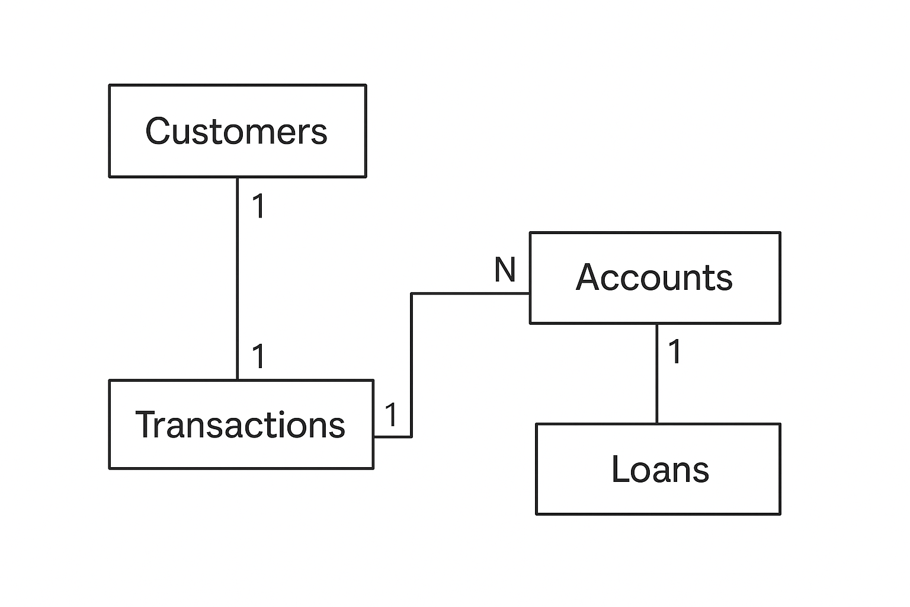

**🎯 Roadmap to Learn SQL Joins (From Start to Pro)**

**✅ Step 1: Understand the Problem Joins Solve**

* SQL **Joins** combine data from **multiple tables** using a common column (key).
* Example in banking:
  + Customers are in one table.
  + Accounts are in another.
  + If you want **customer name + account balance**, you need a **JOIN**.

👉 Without joins, you’d have to manually combine tables — impossible in real data (millions of rows).

**✅ Step 2: Start with the Most Common Joins**

**1. INNER JOIN (most used)**

* Returns only **matching rows** between tables.
* Example: Customers who **have accounts**.

Perfect 🎯 Let’s learn **INNER JOIN** step by step — as if you have **never coded before**.  
I’ll go **slow** and explain:

* **What to write**
* **Why we write it**
* **What result it gives**
* **What to add next**

**🟢 Step 1: Start with One Table (Customers)**

First, let’s just see **customers**.

✅ Here we only see **customer data**.  
But we don’t know their account info (savings, current, FD, etc.).

**🟢 Step 2: Look at Second Table (Accounts)**

**✅ This table shows accounts, but we don’t know the names of the customers — only customer_id.**

🟢 Step 3: Combine Both (INNER JOIN)

We want → Customer Name + Account Type + Balance.

👉 Here comes INNER JOIN:

SELECT c.customer_name, a.account_type, a.balance

FROM Customers c

INNER JOIN Accounts a

ON c.customer_id = a.customer_id;

* Customers c → means we are using Customers table (short name = c).
* Accounts a → means we are using Accounts table (short name = a).
* ON c.customer_id = a.customer_id → tells SQL how to connect the two tables (the link is customer_id).

🟢 Step 5: Understand What INNER JOIN Does

* INNER JOIN returns only rows that exist in both tables.
* Example: Rahul Mehta (customer 5) does not appear in result → because he has no account.

**So INNER JOIN = Common part only.**

**🟢 Step 6: Practice Questions**

**Try to write queries (I’ll check your answers later 😊):**

1. **Show all customers and their account types.**
2. **Show customer names with balances more than 50,000.**
3. **Show city, account_id, and balance of all customers with accounts.**
4. **Show customer names with their account type sorted by balance (highest first).**
5. **Find customers who have more than one account.**

**Note: I have addressed 4 questions**